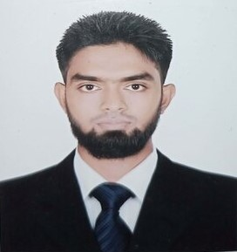

**Master of Business Administration**

Subject : Management

Year : 2020

Result : 3.11 Out of 4.00

Board : Dhaka University

Institution : Dhaka College

**Bachelor of Business Administration**

Subject : Management

Year : 2019

Result : 2.89 Out of 4.00

Board : Dhaka University

Institution : Dhaka College

* Bangla
* English
* Hindi

**PROFESSIONAL EXPERIENCE**

* MS Office( Word,Excell,Powerpoint)
* HTML
* Browsing

**COMPUTER SKILLS**

I hereby declare that all the information provided is true to my knowledge. This document can be supported by appropriate certificates and papers when required.

**ACKNOWLEDGEMENT**

Quick Learner , Innovative, Hardworking , Proactive , Adaptive .

**STRENGTH**

**LANGUAGE**

**1**.**BOOTH OPERATOR**:(September 1-2024- To be continuing)

* **Drinkwell** (Project of Dhaka WASA)

Description:

* Customer Service
* Cash Control
* Internal Inventory
* Reporting

**2**.**SHOWROOM MANAGER**:(17/03/2023 to 05/08/2024)

* **Pran-RFL**(Rainbow Paints)

Description:

* Overseeing sales and daily operations
* Ensuring customer satisfaction and staff coordination
* Managing stock and inventory efficiently
* Reporting
* Cost Control
* Cash Control
* Achieving sales targets within deadlines

**3**.**SALES OFFICER** (05/07/2021 to 30/11/2022)

* **Olympic Industries Ltd.**

Description:

* Driving sales and promoting product visibility
* Developing and maintaining client relationships
* Achieving sales targets within deadlines

To work in a challenging and dynamic environment where I can apply my skills and experience to contribute effectively to organizational growth while developing my career as a dedicated and innovative professional.

**CAREER OBJECTIVES**

**EDUCATION**

* Project Management
* Public Relations
* Teamwork
* Time Management
* MS-Office
* Effective Communication
* Decision making
* Internal Inventory

**SKILLS**

Cell:01824342649

Email: abuh458@gmail.com

Address: House-6, Kashimari-9450, Shyamnagar, Satkhira.

MD. ABU HASAN